**DAILY ONLINE ACTIVITIES SUMMARY**

|  |  |  |  |  |  |
| --- | --- | --- | --- | --- | --- |
| **Date:** | **30-05-2020** | | | **Name:** | **Latika Kavoor** |
| **Sem & Sec** | **4th Sem & A-Section** | | | **USN:** | **4AL18CS035** |
| **Online Test Summary** | | | | | |
| **Subject** | | **DC**  **MATHS** | | | |
| **Max. Marks** | | **30**  **30** | | **Score** | **-**  **30** |
| **Certification Course Summary** | | | | | |
| **Course** | **BOT Aspirant** | | | | |
| **Certificate Provider** | | | **AUTOMATION ANYWHERE** | **Duration** | **12hrs** |
| **Coding Challenges** | | | | | |
| **Problem Statement:** Write a C Program to count Uppercase, Lowercase, special character and numeric values for a given String | | | | | |
| **Status: Completed** | | | | | |
| **Uploaded the report in Github** | | | | **Yes** | |
| **If yes Repository name** | | | | <https://github.com/alvas-education-foundation/latika.kavoor/tree/master/coding_solutions> | |
| **Uploaded the report in slack** | | | | **Yes** | |

Online Test Details: (Attach the snapshot and briefly write the report for the same)

The first test of DC was conducted from 9:15 onwards.I couldn’t give it due to issues in my Network and Mobile.

The second test was of Maths IA2 of 30 marks from 3:00pm. It had 2 parts 1 one was for 10marks and the other one was for 20marks.

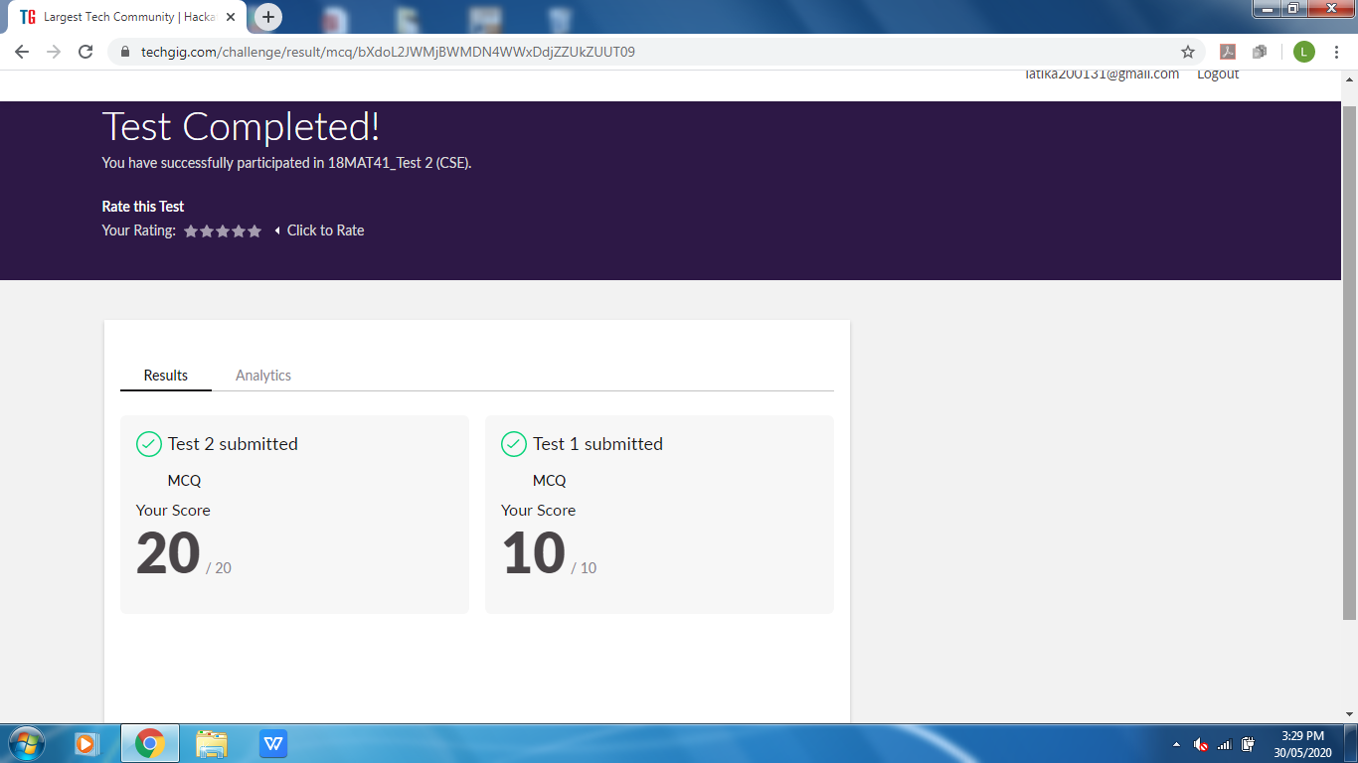

Certification Course Details: (Attach the snapshot and briefly write the report for the same)

I am doing a course from AUTOMATION ANYWHERE UNIVERSITY. I have covered many topics and parts under it. There were few quiz also to be solved and I have completed that as well.

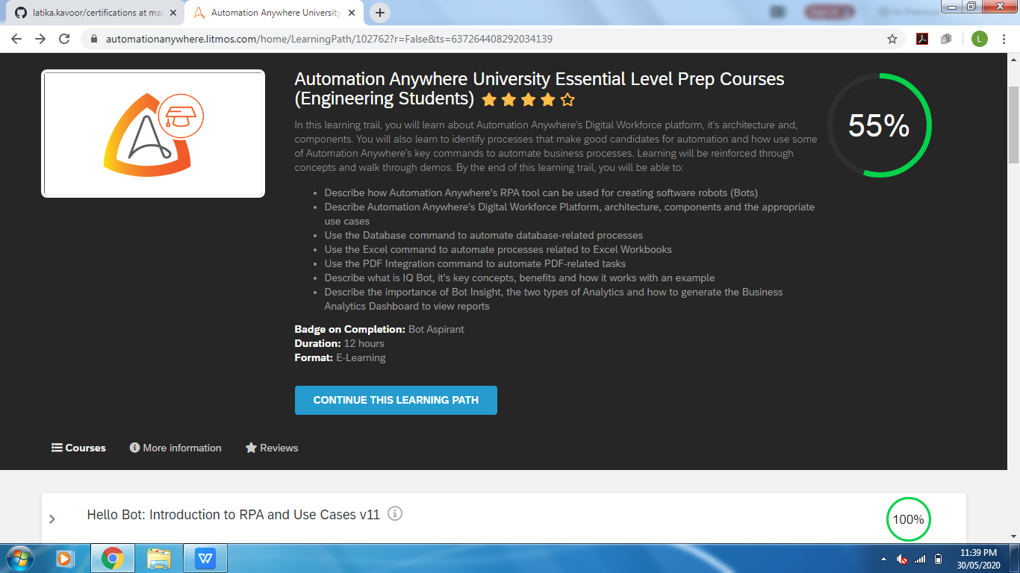

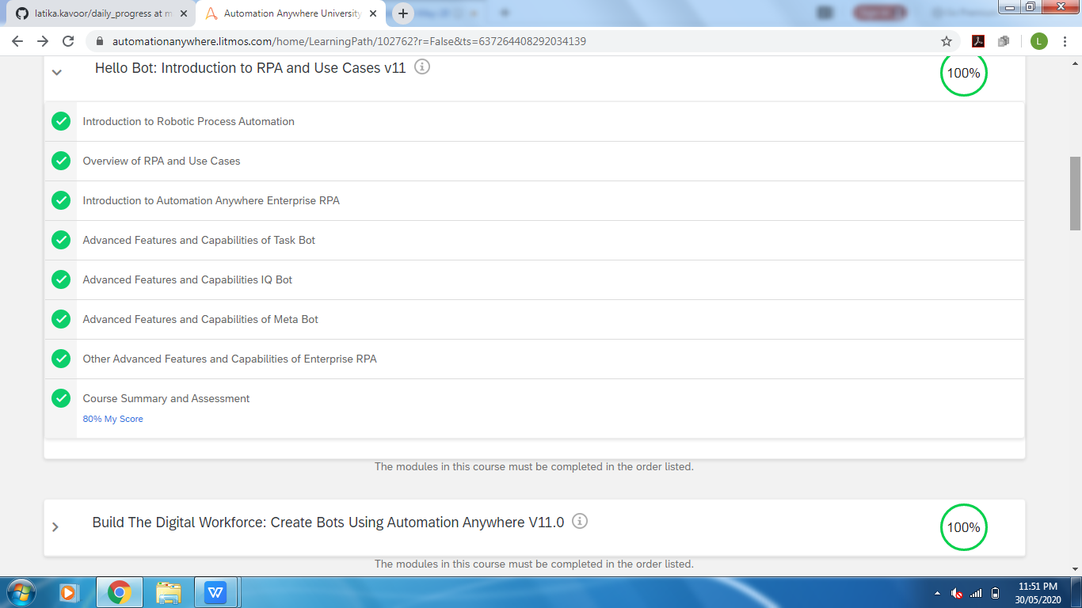

Coding Challenges Details: (Attach the snapshot and briefly write the report for the same)

Solved the problem and uploaded the same on github

